My Batik Model Report

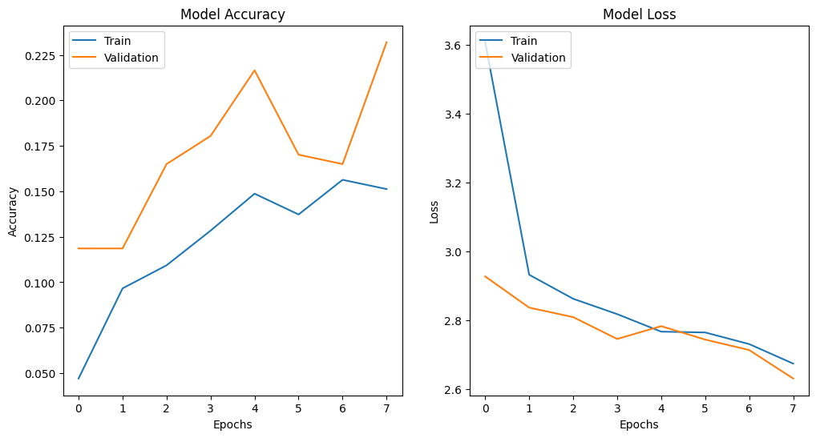

**Epoch 8**

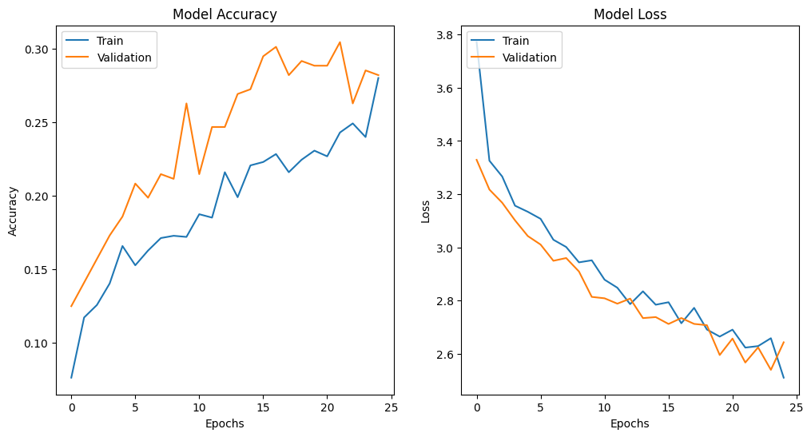

**Epoch 25**

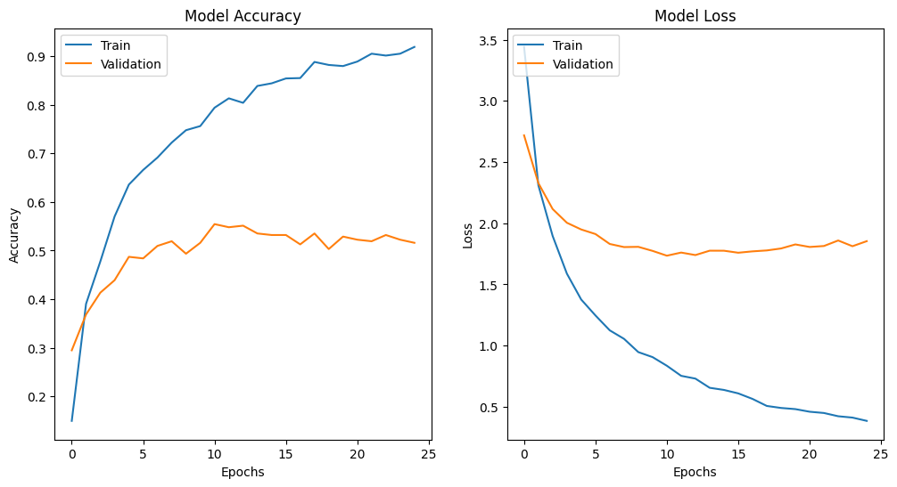

**Mobile net**

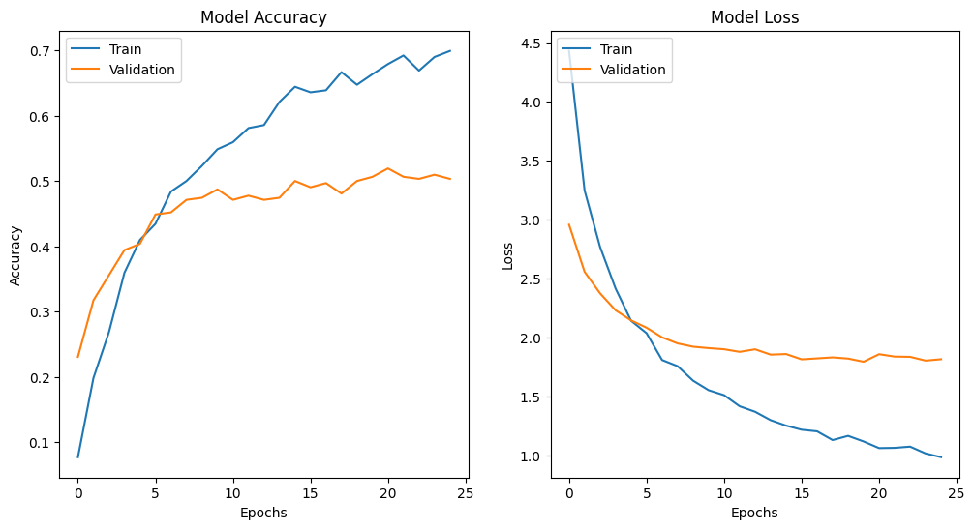

**Mobile net with Dropout**

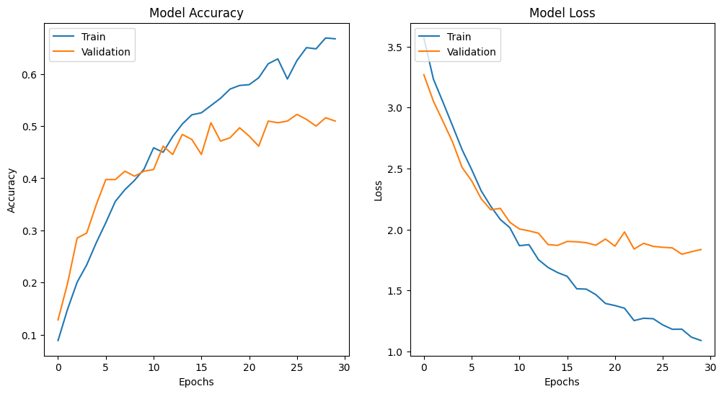

**Mobile Net Epoch 30**

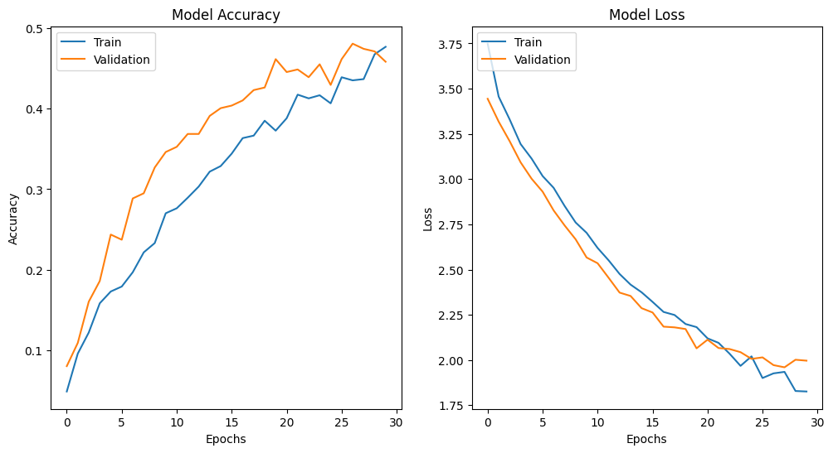

**Mobile Net batch Size 64**

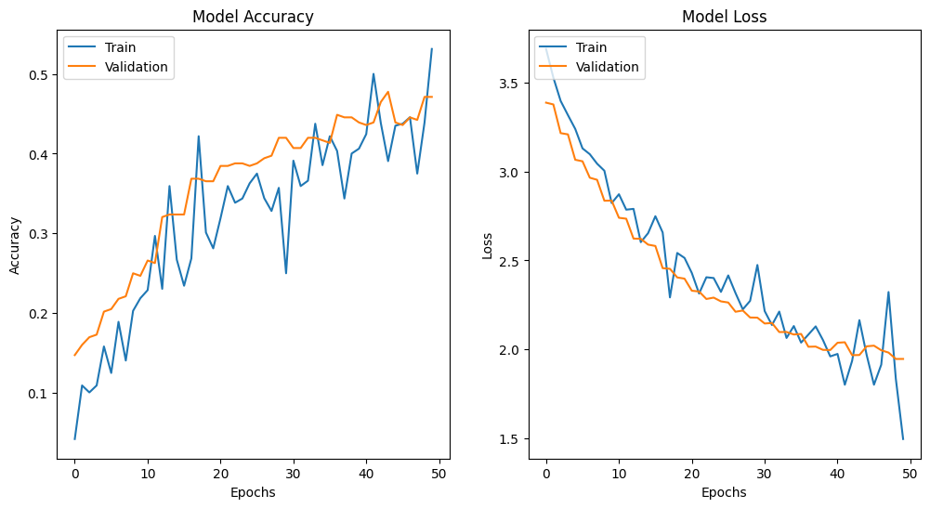

**Epoch 50 Mobile Net**